



🏠

Krishnanagar Anath Sishu Ashram (KASA)
"No child should be deprived of education, care and dignity because of poverty"

ANNUAL REPORT 2025–26

Krishnanagar, West Bengal, India | Est. 2010

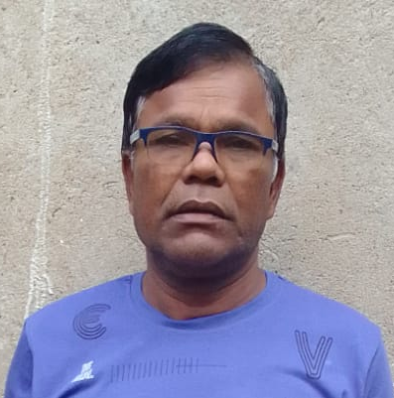

Message from the Founder Secretary

"It is my privilege to present the Annual Report of Krishnanagar Anath Sishu Ashram (KASA) for the year 2025–26. KASA was founded with a simple yet powerful vision—to ensure that no child is deprived of education, care, protection, and dignity due to financial hardship. This vision is deeply rooted in my own life experiences and continues to guide our commitment towards serving vulnerable children and communities with compassion and responsibility.
Over the years, KASA has evolved into a community-based institution focused on providing structured care, educational support, nutritional assistance, and emotional wellbeing to children in need. During the year, the organisation supported 83 children through its child care and development initiatives and extended community welfare support to more than 500 individuals through various outreach programmes.
This year also marked an important milestone as KASA collaborated with Krishnayan Ashram for technical guidance and institutional support to strengthen our organisational systems and help us move more effectively toward achieving our long-term goals.
I would like to place on record my sincere gratitude to our donors, well-wishers, volunteers, and community members whose continued trust and cooperation make our work possible. Today, KASA is supported by a committed volunteer base of more than 50 individuals across Krishnanagar, whose dedication continues to strengthen our grassroots presence.
Looking ahead, we aspire to expand our work by establishing a Cottage Home for children and an Anand Ashram for the elderly, with the aim of creating a holistic care ecosystem that supports both vulnerable children and senior citizens who require care, dignity, and companionship. Despite various operational and financial challenges, we remain committed to strengthening our programmes, improving institutional systems, and building development partners.
As we move forward, we look forward to continued support and meaningful partnerships in advancing our shared mission of creating opportunities and ensuring dignity for every child and elderly person in need."
— Bhaktipada Maity
Founder Secretary, KASA

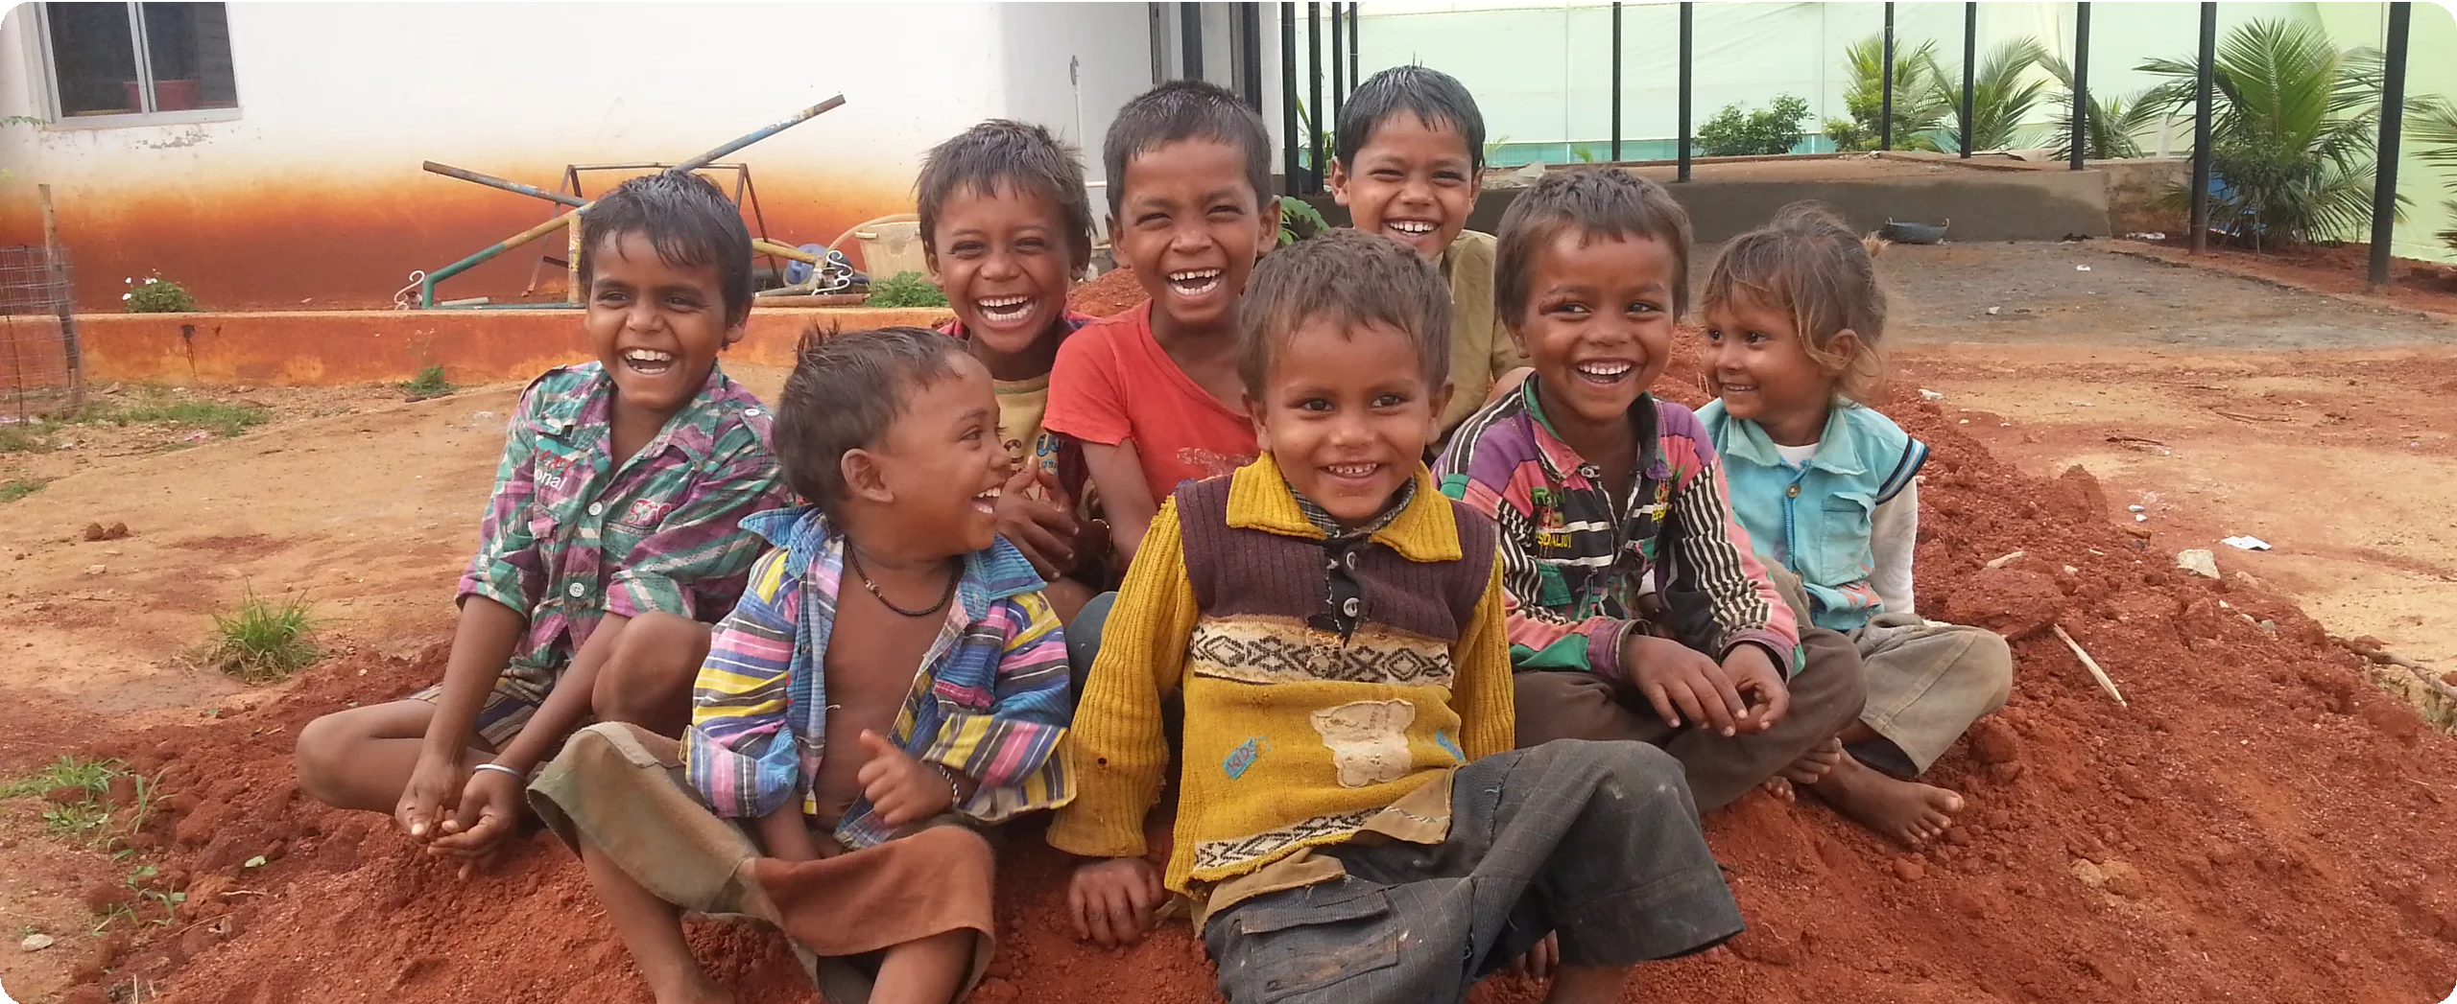

Children supported by KASA — a community of hope, learning, and dignity.

Table of Contents
Message from the Founder Secretary 2
Vision, Mission & Objectives 5
Bhaktipada Maity – A Life of Service 8
Organizational Background 9
Activities in FY 2025-26 10
Key Challenges Addressed: 12
Community & Livelihood Initiatives 14
Challenges & Impact Analysis 19

Financials_______________________________________________________________________________________20

Impact at a Glance (2025-26)

500+
CHILDREN SUPPORTED
1500+
COMMUNITY OUTREACH
150+
DIGITAL LITERACY TRAINEES
50+
ACTIVE VOLUNTEERS

Vision, Mission & Objectives
Vision 👁
To create a compassionate, inclusive, and equitable society where vulnerable children, elderly individuals, women, and underserved communities are protected, supported, and empowered to live with dignity,
security, and opportunity.
Mission 🎯
Krishnanagar Anath Sishu Ashram (KASA) is committed to providing a
safe, nurturing, and
environment for
enabling
vulnerable
children through care, education, nutrition, and holistic development. The organisation also strives to extend care and social support to elderly individuals, women, and disadvantaged communities through structured welfare interventions, livelihood support,
and strategic partnerships.

Strategic Objectives
1 Siksha Niketan – Flagship Education Programme: To strengthen access to education for vulnerable children through KASA's flagship Siksha Niketan initiative.
2 Child Care and Holistic Development: Provide safe shelter, nutrition, healthcare, psychosocial care, and educational opportunities to vulnerable children.
3 Women Empowerment and Livelihoods: Promote economic independence of women through skill development, livelihood promotion, and awareness programmes.

4 Elder Care and Support: Promote dignity and wellbeing of senior citizens through care initiatives and the proposed establishment of Anand Ashram.

5 Community Welfare and Outreach: Undertake health camps, awareness programmes, emergency support, and welfare distribution drives.
6
Institutional Strengthening: Strengthen organisational capacity through
technical partnerships and structured volunteer engagement.
7 Sustainable Partnerships: Build long-term partnerships with donors, CSR institutions, and government bodies.

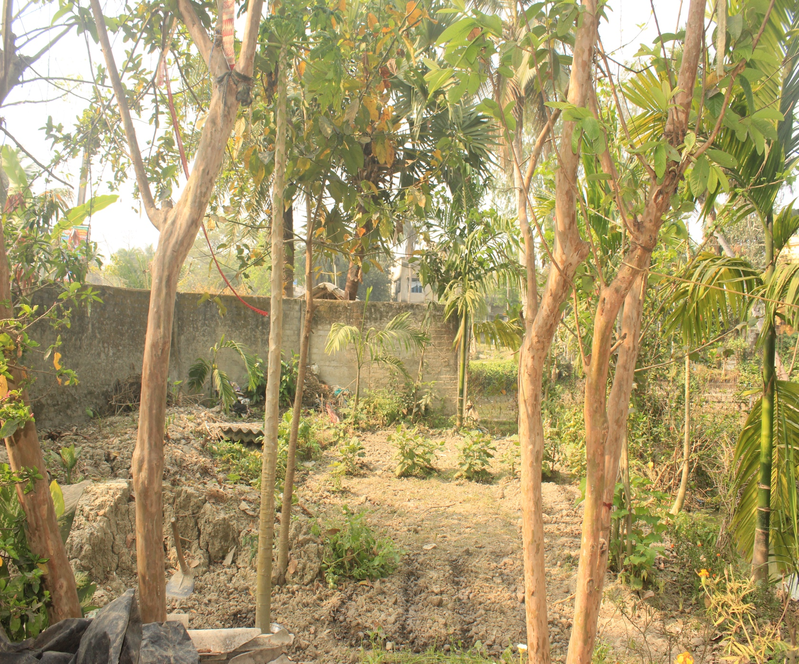

Bhaktipada Maity – A Life of Service

A Journey of Compassion and Sacrifice
The story of KASA is inseparable from the life journey of its founder, Mr. Bhaktipada Maity. Born and raised in Krishnanagar village, his early life was shaped by economic hardship. Due to financial difficulties, he was unable to pursue formal education. To support himself and his family, Bhaktipada Maity took up the physically demanding work of pulling a rickshaw.
His philanthropic journey began around 1991, when he started helping needy individuals in his village using whatever little he could spare from his modest daily income. After nearly 19 years of continuous grassroots social work, Bhaktipada Maity realised that informal support alone would not be enough. This vision led to the formation of Krishnanagar Anath Sishu Ashram (KASA) on 9th August 2010.

"Social leadership is not defined by wealth or status but by commitment and consistency."

Over the years, KASA has provided support to more than 300 residential children and impacted the lives of more than 1,500 underprivileged children. Financial sustainability has been one of the biggest hurdles. There were times when arranging food for the children itself became difficult. Bhaktipada Maity's leadership style is deeply participatory.
For the children under his care, he emphasizes discipline, respect, education, and compassion as guiding principles. His story is one of unrelenting hope — a reminder that the most profound social transformations often begin not in boardrooms, but in the hearts of ordinary individuals willing to give everything they have.

Organizational Background

KASA was established as a response to the growing need for structured support for vulnerable children in the Krishnanagar region of West Bengal. The formal registration of the society on 9 August 2010 under the West Bengal Societies Registration Act, 1961 provided an institutional framework to expand these activities systematically. The organisation continues to operate with a strong grassroots philosophy, believing that meaningful social development must begin at the community level through trust,
participation, and sustained commitment.

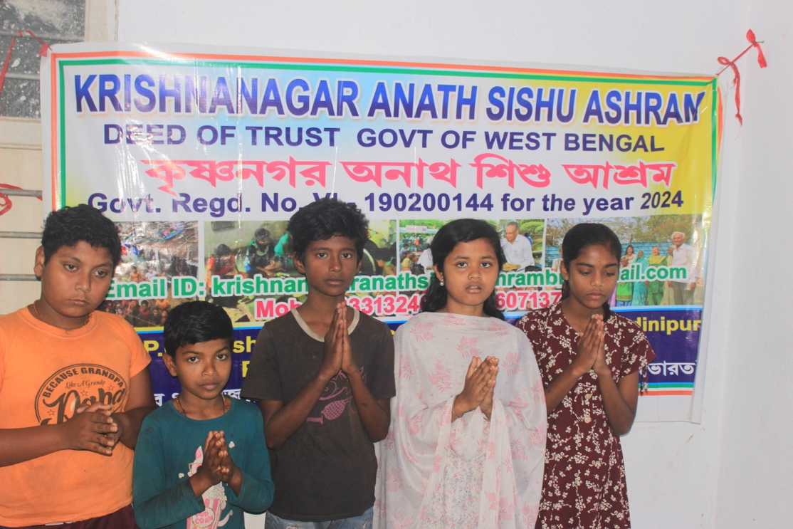

📋 Key Registration Details
Registered under: West Bengal Societies Registration Act, 1961
Date of Registration: 9th August 2010
Location: Krishnanagar, West Bengal, India

Activities in FY 2025-26
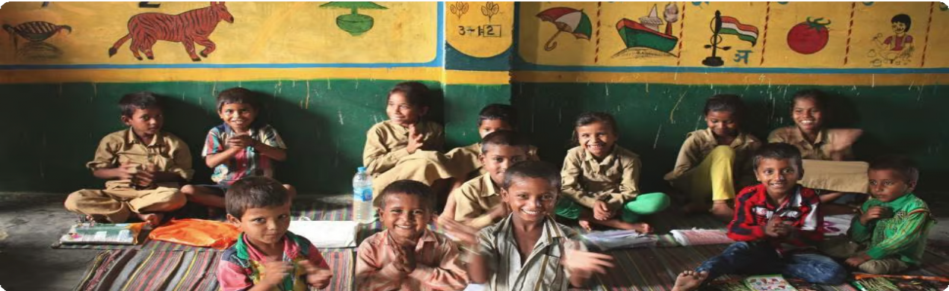

Children attending structured learning sessions under KASA's education support programme.

- Child Care and Education Support 📚
During FY 2025-26, the organisation continued to provide structured support to 83 children. The programme focuses on three dimensions:
  - Educational Support: Monitoring attendance and supporting learning through structured tutoring sessions.
  - Residential Care and Welfare: Structured daily routines including study, physical activities, and hygiene practices.
  - Emotional and Social Development: Mentoring and confidence-building activities to help children from vulnerable backgrounds integrate into mainstream society.

CASE STUDY — RAJU' S STORY

Raju, an 8-year-old boy from a financially distressed family, joined KASA's care programme after his family struggled to provide basic meals. Through KASA's nutrition support and educational guidance, Raju began attending school regularly and demonstrated significant improvement in his studies. Today, Raju continues his education with renewed motivation and a bright outlook for the future.
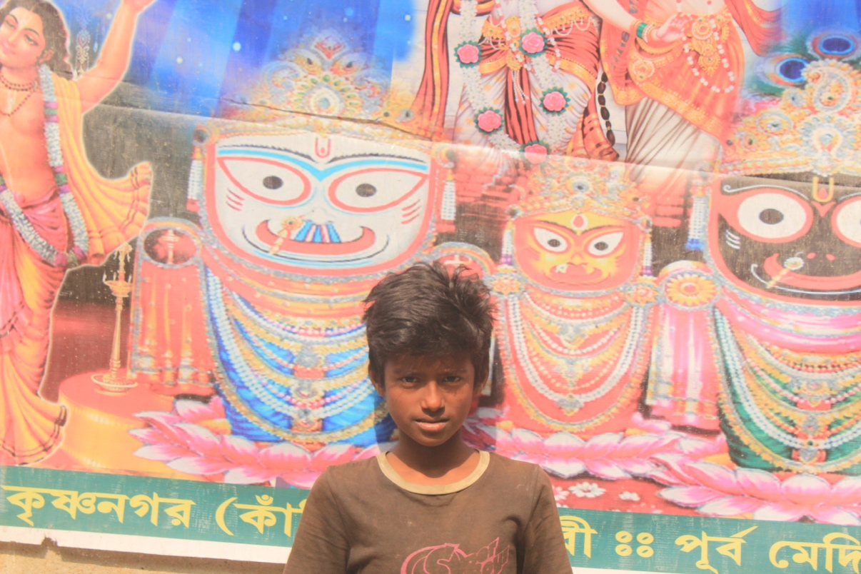

- Siksha Kutir (Education Hut) 🏠
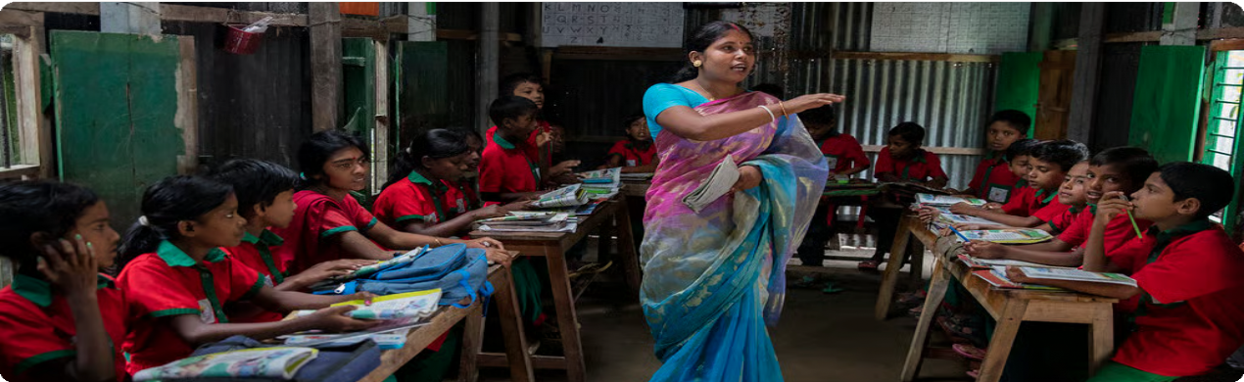
The Siksha Kutir initiative provides structured academic support to children from economically weaker sections who are enrolled in local government schools but lack adequate learning support at home. Activities include homework assistance, basic subject strengthening, group learning sessions, and mentoring to prevent school dropout.

Students engage in group learning — the Siksha Kutir initiative builds confidence and academic skills.

Key Challenges Addressed:

  - Lack of Learning Support for first-generation learners.
  - Learning Confidence Gap in children from low-income families.
  - Financial pressures putting children at risk of dropout.

CASE STUDY — SITA' S STORY

Sita, a 10-year-old girl from a marginalized household, struggled with basic reading and writing skills. After enrolling in Siksha Kutir, she received daily coaching and emotional encouragement from volunteers. Within months, she gained confidence and continued her education with improved academic performance.

- Nutrition Support 🍎
KASA continued its food support programme ensuring regular meals for all children under its care. Providing regular nutrition resulted in better concentration, improved health, and reduced absenteeism among children.
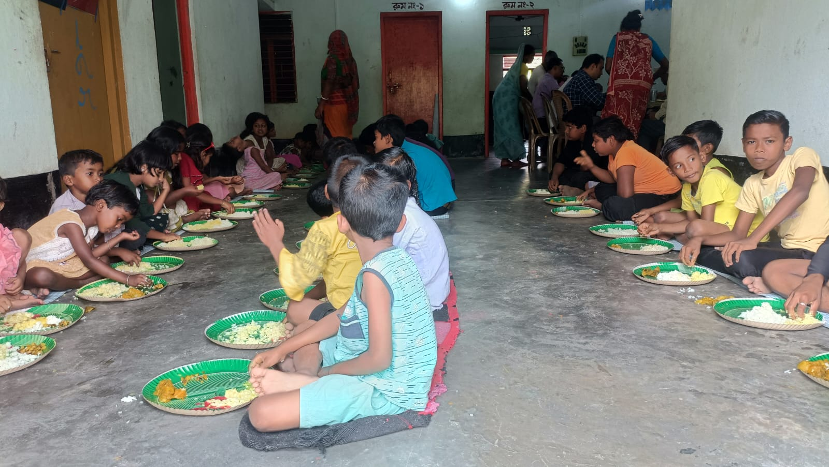

- Physical Development and Health Activities 🧘
Activities conducted include morning physical drills, group exercises, yoga sessions, and team-building games to promote discipline, physical fitness, and a sense of community.
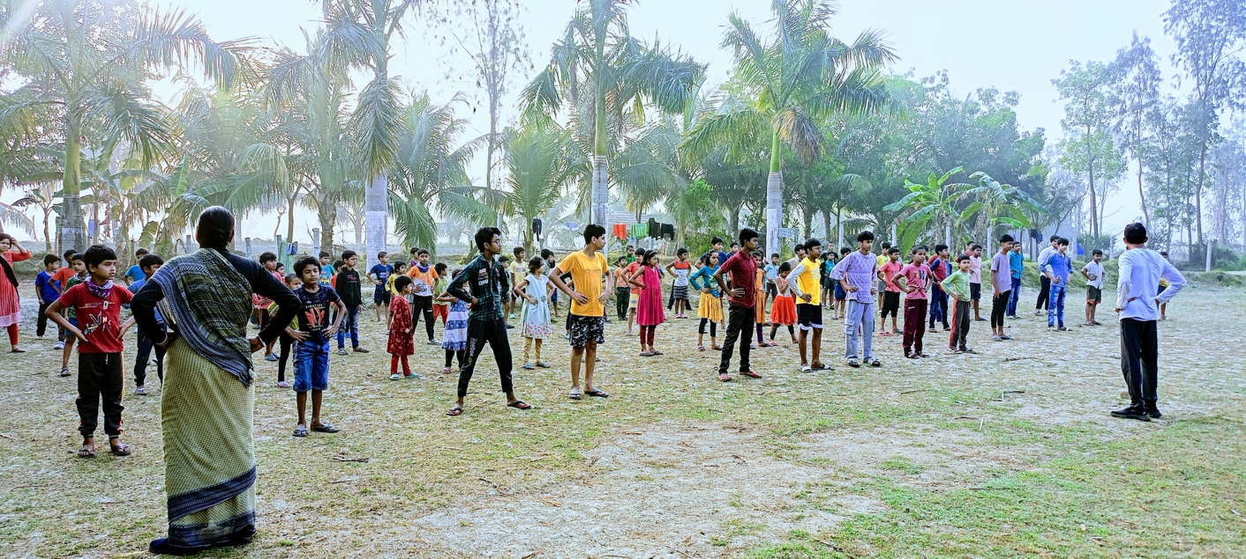

Community & Livelihood Initiatives
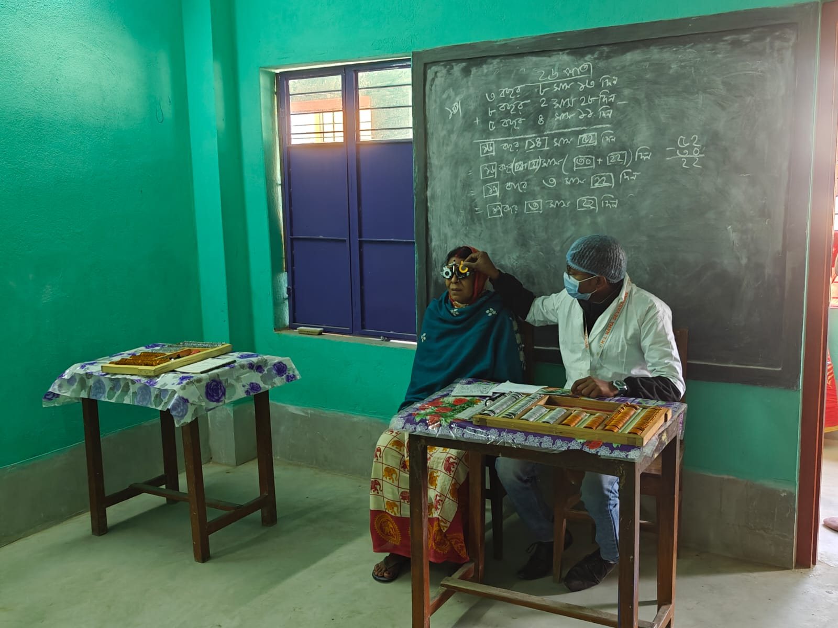

- Community Welfare Activities 🤝
During FY 2025-26, the organisation impacted more than 500 individuals through outreach support, including informal counselling, emergency welfare support, and awareness programmes for vulnerable families in Purba Medinipur district.

- Paddy Cultivation as a Livelihood 🌱
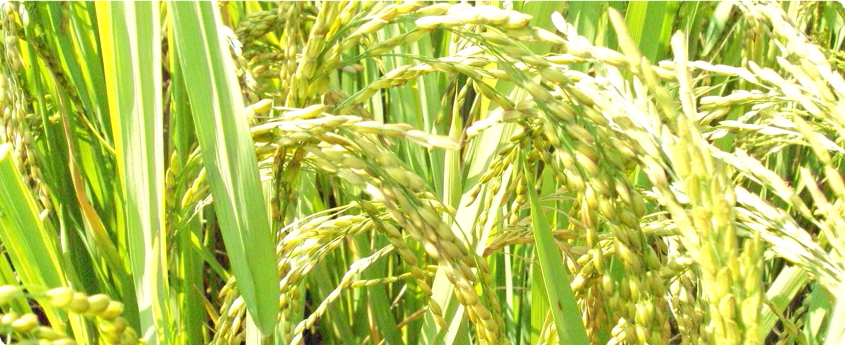

Paddy cultivation — a vital traditional livelihood supported by KASA in West Bengal villages.

KASA recognises the importance of paddy cultivation as a key source of income for rural families in the region. The organisation supports and promotes this traditional agricultural practice among beneficiary families to strengthen food security and household economic resilience.

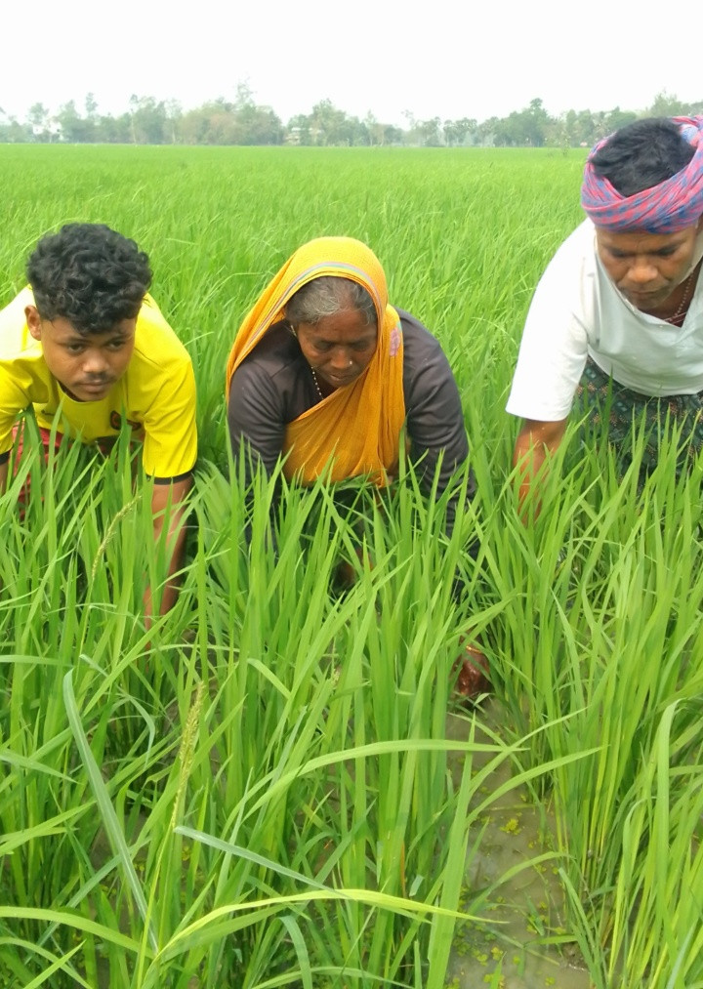

- Aquaculture Livelihood Promotion 🐟

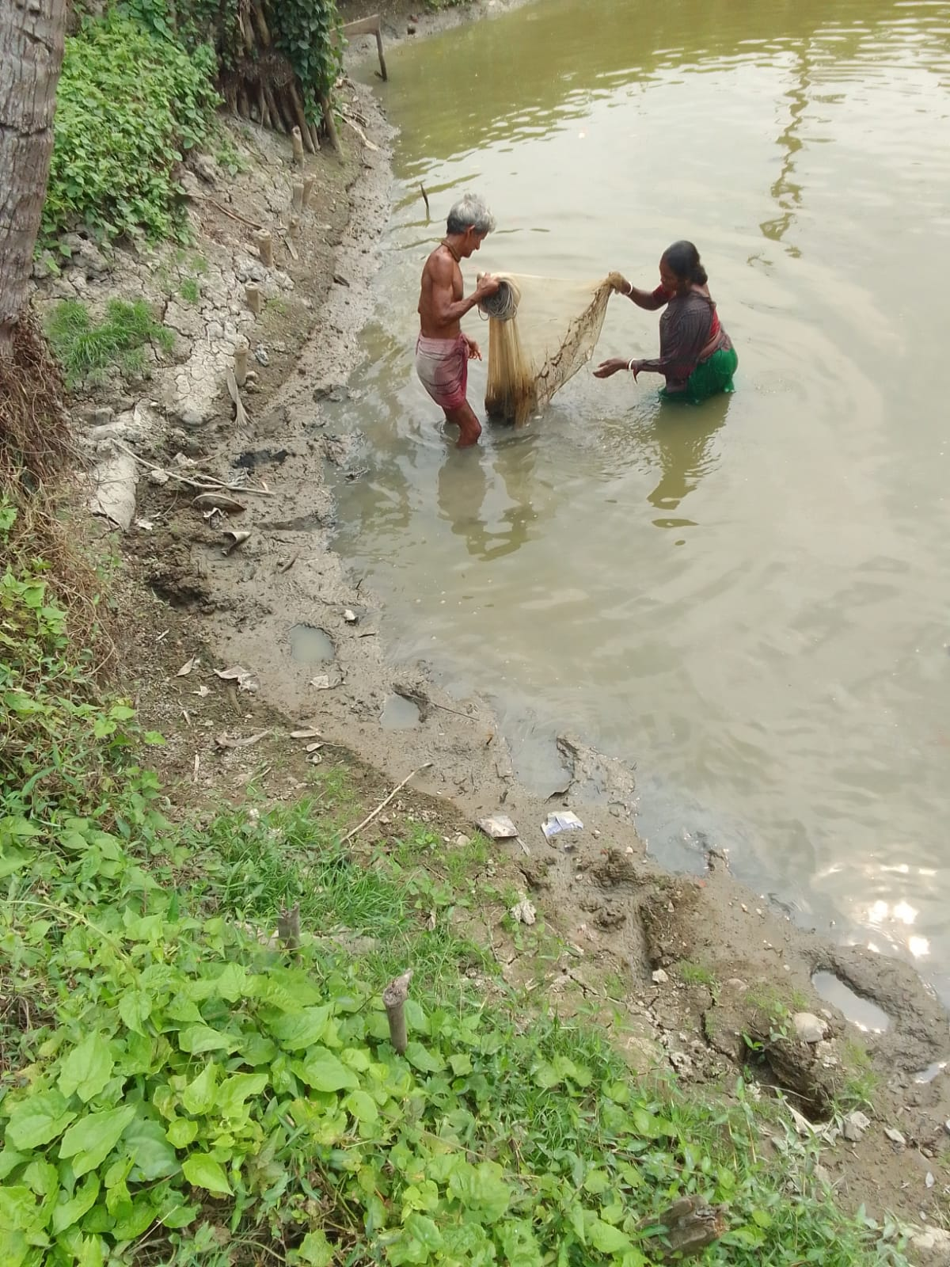
KASA has been encouraging community members to engage in fish farming (aquaculture) as an alternative and reliable livelihood option. By promoting scientific aquaculture practices and building market linkages, KASA helps families generate regular income, particularly during agricultural off-seasons.

- Volunteer Engagement 🖐
Volunteers form a vital pillar of support for KASA's operations. The organisation currently has a dedicated volunteer base of more than 50 individuals across Krishnanagar who assist in programme delivery, logistics, awareness campaigns, and community mobilisation.

- Computer Training Centre 💻
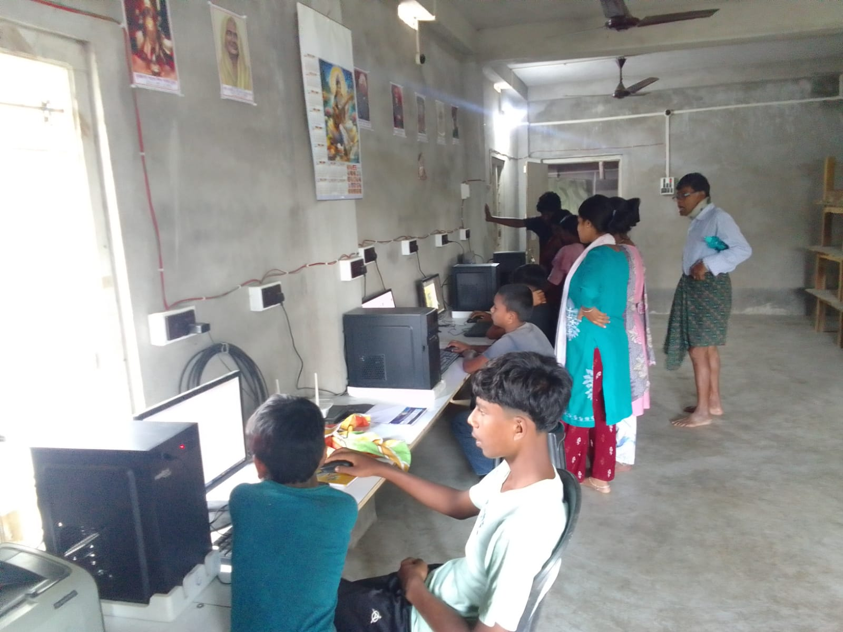
KASA established a Computer Training Centre to bridge the digital divide. To date, the centre has supported more than 150 individuals — including youth and community members — in gaining essential computer skills, fundamental digital literacy, and software applications to improve employability and access to digital services.
- Community Health Support Initiative 🏥

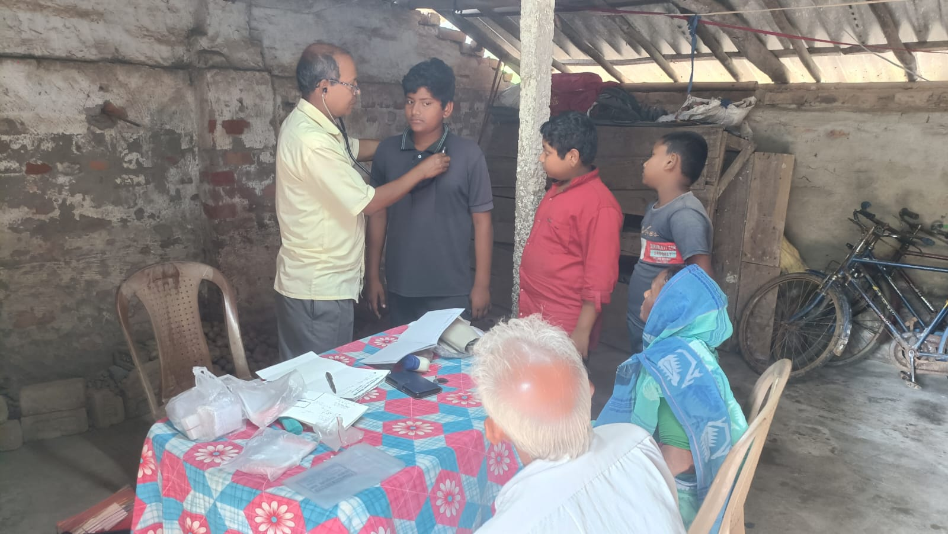

KASA established a basic medical check-up facility within its campus to provide free primary healthcare services to children and residents from nearby villages. The facility offers basic health consultations and preventive diagnosis, addressing the lack of accessible healthcare in the immediate community.

- Institutional Partnership 🏢
KASA established a technical cooperation partnership with Krishnayan Ashram during FY 2025-26. This collaboration provides guidance in organizational systems, programme planning, governance practices, and institutional capacity-building. The partnership has particularly helped KASA focus on building a stronger institutional base by improving internal processes, encouraging structured programme implementation, and promoting accountability and transparency in its operations. Such technical support is critical in enabling grassroots organisations like KASA to grow into more sustainable and professionally managed institutions.

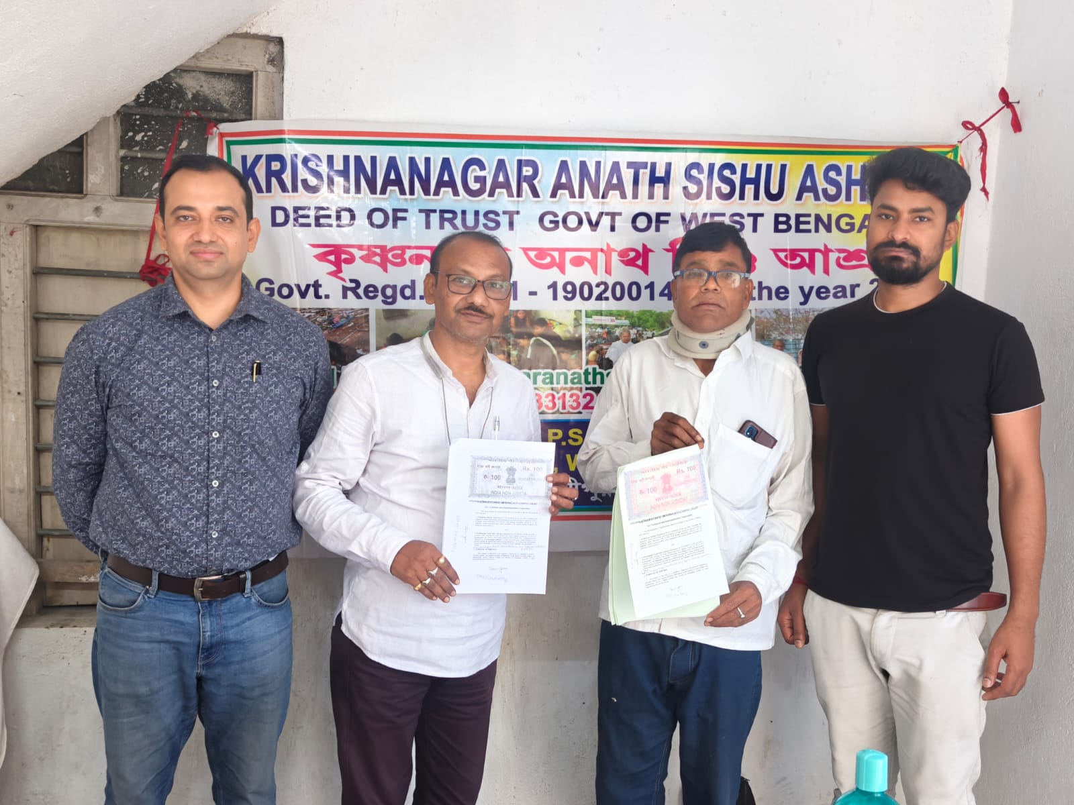

Challenges & Impact Analysis
Key Challenges
Funding Sustainability: Reliance on donations and goodwill makes financial planning difficult.
Infrastructure: Facilities require maintenance and expansion to meet growing needs.
Increasing Need: Demand for services exceeds current capacity. Compliance: Increasing administrative and regulatory requirements require dedicated resources.

Impact Analysis 2025-26

DIRECT IMPACT
150+ Children provided with structured education, nutrition, and residential care.
INDIRECT IMPACT
1500+ Individuals reached through community outreach and welfare.

SOCIAL IMPACT
Increased awareness regarding child education and reduction in dropout rates.
HISTORICAL IMPACT
3000+ Residential Children supported since inception (2010).

Future Strategy & Roadmap 🚀

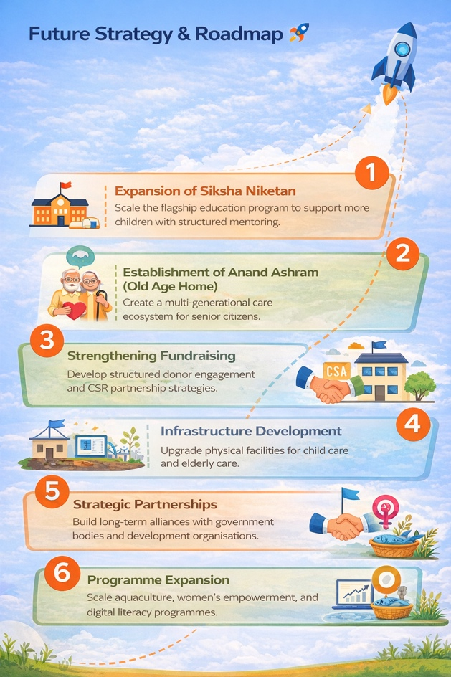
- Expansion of Siksha Niketan: Scale the flagship education program to support more children with structured mentoring.
- Establishment of Anand Ashram (Old Age Home): Create a multi-generational care
ecosystem for senior citizens.
- Strengthening Fundraising: Develop structured donor engagement and CSR partnership strategies.
- Infrastructure Development: Upgrade physical facilities for child care and elderly care.
- Strategic Partnerships: Build long-term alliances with government bodies and development organisations.
- Programme Expansion: Scale aquaculture, women's empowerment, and digital literacy programmes.


Audit report 2025-2026





